 | 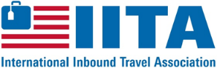 |  | 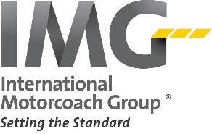  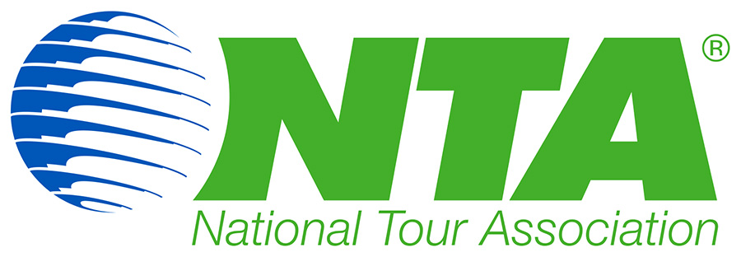
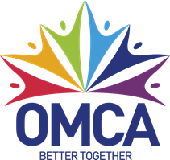
 |  | 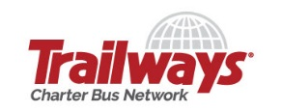 | 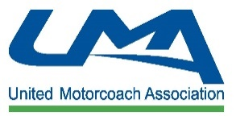

Industry Associations are Collaborating to Advance Mutual Interests

Washington, D.C. – On Dec. 7, leaders of the motorcoach, tour and travel industry came together to discuss issues affecting all aspects of the industry and their respective members. This was a rare opportunity for industry leaders to collaborate on collective issues facing their members.

In attendance were: Peter Pantuso, American Bus Association; Lisa Simon, International Inbound Travel Association; Bronwyn Wilson, International Motorcoach Group; Pam Inman, National Tour Association; Doug Switzer, Ontario Motor Coach Association; Carylann Assante, Student Youth Travel Association; Eva Hotard, Trailways Charter Bus Network; Stacy Tetschner, and United Motorcoach Association. Terry Dale of the United States Tour Operators Association was not able to attend but has been active and engaged with the industry associations and supportive of the issues discussed.

Because of the commonality and shared memberships among industry groups, the leaders agreed that the health and wellbeing of the industry impacts each organization and its members, and as a united group they can accomplish more on common issues than working in silos.

For example, the National Park Service’s (NPS) is raising fees for groups, requiring onerous record keeping by operators, mandating that tour operators and (sometimes) motorcoach operators pay Commercial Use Authorization fees for each park visited, and adopting parking management programs at some parks that can limit visitors’ access for groups. All the associations are working together on this issue and/or supporting the efforts of those organizations more directly involved. Joint meetings with NPS and the Interior Department will continue and each of the associations will share information as it is made available.

The association leaders agreed that sharing issues and challenges that face their collective memberships will create a stronger industry lobbying presence, whether on Capitol Hill or at the federal and state agency level.

Finally, the organizations looked at future trends that will impact memberships and their respective events.

Because of the success of this inaugural meeting, the group will meet annually to assess, review and work together on immediate and future issues involving their memberships.

For more information contact:

Peter Pantuso, President & CEO, American Bus Association, PPantuso@buses.org
Lisa Simon, Executive Director, International Inbound Travel Association, lisa.simon@inboundtravel.org
Bronwyn Wilson, President, International Motorcoach Group, bwilson@imgcoach.com
Pam Inman, President, National Tour Association, pam.inman@ntastaff.com
Doug Switzer, President & CEO, Ontario Motor Coach Association, doug@omca.com
Carylann Assante, Executive Director, Student Youth Travel Association, cassante@syta.org
Eva Hotard, President & CEO, Trailways Charter Bus Network, eva@trailways.com
Stacy Tetschner, President & CEO, stetschner@uma.org
Terry Dale, President, United States Tour Operators Association, tdale@ustoa.com

